
ESTIMATING THE RELIABILITY & ROBUSTNESS OF RESEARCH

AUTHOR RESPONSE

French, K. A., Dumani, S., Allen, T. D., & Shockley, K. M. (2018). A meta-analysis of work–family conflict and social support. Psychological Bulletin, 144(3), 284-314.

response by

Kimberly A. French, Colorado State University

Review version 1.0 (November 13, 2025)
Review template version 1.0
License: CC BY 4.0

My coauthors and I greatly appreciate the opportunity to participate in the ERROR project. We especially thank Ian Hussey for his guidance throughout this process, and Matthew Jané for his time and expertise in carefully and thoroughly examining our data and analyses.

We believe the issues identified are relatively minor in that they do not meaningfully change our conclusions (reliability composites) or appear to be uncommon and unsystematic (typo, handling of Brown, 2013). Here we respond to major points raised in the ERROR report.

Use of Spearman-Brown Correction for Unreliability

We agree and appreciate Matthew for raising this major flaw in our corrected estimates. We looked further into the extent to which this error is problematic for the results and our conclusions.

First, we examined our data to see how many of our reliability estimates were composited for each meta-analysis. Fewer composites would suggest there would be little change when using Mosier’s formula, as not many effects would be adjusted. See the table below and our R html output for computations.

As can be seen in the table, slightly less than a quarter of reliability coefficients were composited for WIF (24.21%) and FIW (23.39%) (average RYY), and approximately 17% of coefficients were composited for support correlates (average RXX). There is a range in the frequency of composites, such that analyses using combined or mixed correlates have the highest proportions of reliability composites (22% - 55%). This is expected, given that combined correlates combine multiple meta-analytic subsets.

Next, we looked at the magnitude of change in our uncorrected and corrected estimates. As Matthew rightfully points out, our reliability composites systematically inflate the corrected estimates. However, if the corrected estimates are similar in magnitude to uncorrected estimates (e.g., corrected and uncorrected estimate only differ by .02), this would suggest that a more accurate estimate would not change the meaning of the results, nor the paper’s major conclusions. See below for a frequency distribution of the change in effect size magnitude comparing corrected and uncorrected estimates in the paper.

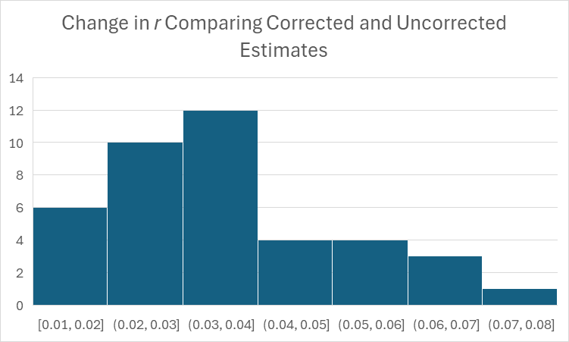

Corrected estimates are only modestly larger than uncorrected estimates (average change in r = .04, minimum = .01, maximum = .08); the distribution has some positive skew. We do note that the larger differences (.06-.08) are for the meta-analyses with a higher proportion of Spearman-Brown reliability composites. The significance of effect sizes is consistent across corrected and uncorrected results.

In sum, we find that for most meta-analyses in the paper, relatively few effect sizes use the incorrect Spearman-Brown composite reliability coefficients. Moreover, we find that the increase in effect size magnitude when using the inflated Spearman-Brown correction is relatively small. We agree and acknowledge this is a major analytic flaw. However, considering the data presented here, we doubt re-running the analyses would change any of the major conclusions in the paper. At the most, our meta-analyses, particularly those using combined support correlates, are inflated to some small degree.

Incorrect Sample Size for Crain et al., 2014

We confirmed this is a simple coding error. All papers were double coded. Both coders made the error.

We checked an additional random set of 10 papers from our meta-analysis. We confirmed 8/10. For the two papers not confirmed, our coded N was close (2981 vs. 2931 and 541 vs. 518 and 513). These two papers did not provide a correlation matrix in the published article. In such cases, we contacted authors for correlation matrices. It is likely that the correlation matrix had specific N values for each correlation which we used on our analysis to be most accurate. I no longer have access to those emails to double check. Please see our RMarkdown output.

This was the only typo error identified in the report, and so we feel cautiously optimistic that our coding was reasonably accurate.

Coding and Composite Error for Brown (2013)
We also had a note on this study that the “work support measure is strangely used.” We confirmed the notes in the ERROR report. The intercorrelation between the SA and SLA types of support were correctly documented as -.42, but we incorrectly included “.42” in the composite calculation itself. It is highlighted, indicating that the first author looked closely to confirm the negative correlation. I can only speculate that we were not looking closely enough at the variables themselves (SA vs. SLA and inappropriate SLA variable), and that the first author assumed that the relatively strong negative correlation had to be an error in the paper. We also confirm that the supervisor support measure should have been coded and was missed by both coders.

This was the only study with a note about “strange” measures. We suspect this may be the only case in our data of this type of error.

Lack of Code
The report notes that code functionality was indeterminable. The first author conducted all analyses and was the only author with access to the code. The first author moved institutions twice since the meta-analysis was conducted. The code was stored on a cloud server (institution Dropbox at the author’s PhD institution). The first author attempted to move files across servers to avoid losing access at the time of each move, but unfortunately discovered the code was not properly saved when the ERROR team requested it. The first author tried multiple avenues to recover the code but was ultimately unsuccessful.

Closing
In closing, we thank the ERROR team for their important work and contribution to our field. We are honored to participate and contribute to a culture of reproducibility and transparency. It is efforts like this that begin to make our science more robust and trustworthy. We encourage the ERROR team to continue this work, and for others to join the movement.

